CREDIT CARD APPROVAL PREDICTION SYSTEM

Project Description:

Credit Card Approval Prediction is a Machine Learning-based web application that helps predict whether a customer's credit card application is likely to be approved based on their personal, financial, family, housing, and credit history information. The system assists financial institutions in making faster, more consistent, and data-driven decisions while reducing manual effort.

The platform includes an Applicant Information Module, where users enter applicant details such as gender, annual income, employment, education, family information, housing type, and credit history. A Machine Learning Prediction Module processes the submitted information using a trained classification model to determine whether the application is likely to be approved or rejected. Finally, the Prediction Result Module displays the outcome in a simple and user-friendly manner.

Built using Python, Flask, Scikit-learn, HTML, and CSS, the application provides an intuitive web interface for real-time credit card approval prediction. The Machine Learning model was trained using a Kaggle credit card approval dataset after performing data preprocessing, feature engineering, and model evaluation. The project follows a modular architecture and is managed using GitHub for version control, making it easy to maintain and extend in the future.

Scenarios

Scenario 1: A salaried employee with a stable annual income, good employment history, and positive credit history submits a credit card application. After entering the required details into the application form, the Machine Learning model analyzes the information and predicts that the application is Approved because the applicant satisfies the eligibility criteria.

Scenario 2: A customer with low annual income, limited employment experience, and an unfavorable credit history submits a credit card application. The system evaluates the provided information and predicts that the application is Rejected, indicating that the applicant may not currently meet the bank's approval requirements.

Scenario 3: A bank employee uses the application to quickly evaluate multiple customer applications. Instead of manually reviewing each applicant's information, the system instantly predicts the approval status using the trained Machine Learning model, helping reduce processing time, improve consistency, and support better decision-making.

Technical Architecture:
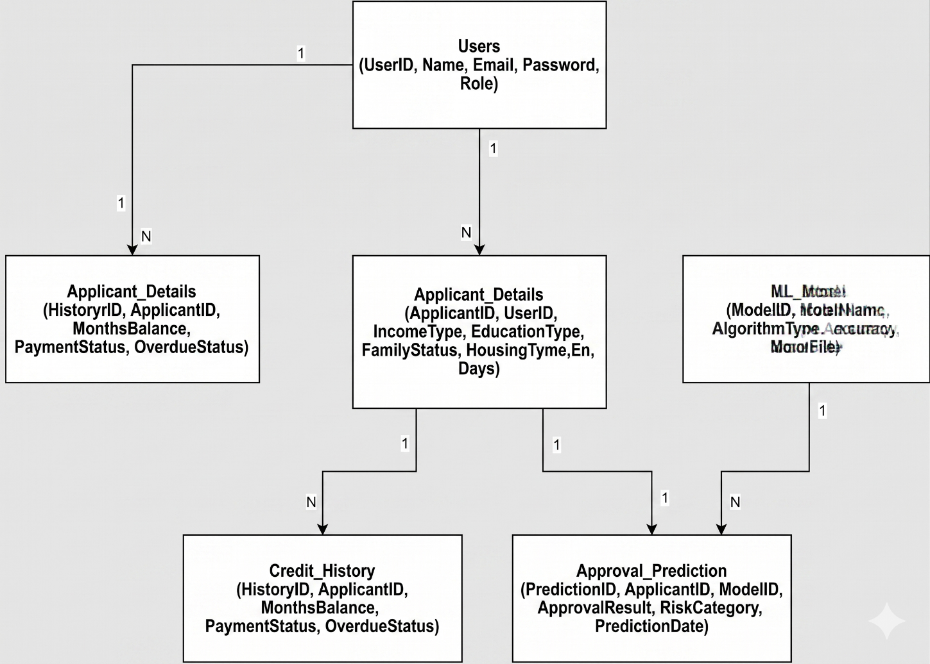

Description: The Credit Card Approval Prediction System utilizes a modular three-tier architecture to provide fast and accurate credit card approval predictions. The frontend offers a responsive and user-friendly interface developed using HTML and CSS, allowing users to enter applicant information easily. The Flask-based backend handles user requests, validates the input data, preprocesses the features, and communicates with the trained Machine Learning model.
The backend integrates a Scikit-learn Machine Learning model that analyzes applicant information, including personal, financial, family, housing, and credit history details, to predict whether the credit card application is likely to be approved or rejected. The project is developed using Python, with data preprocessing performed using Pandas and NumPy, while the trained model is stored using Joblib for efficient loading during prediction. The project follows a modular architecture, making it easy to maintain, extend, and deploy in the future.

(Note: If you are using database in your project definitely you need to add ER Diagram along with description)

Pre-requisites:

- Flask Framework Knowledge: Flask Documentation
- Python Programming: Python Documentation
- Machine Learning Fundamentals: Scikit-learn Documentation
- Data Analysis using Pandas and NumPy
- HTML & CSS Knowledge
- Version Control using Git and GitHub
- Visual Studio Code / Jupyter Notebook
- Basic understanding of Credit Card Approval Prediction

Project Workflow:

Milestone 1: Data Collection and Model Development

Activity 1.1: Collect the applicant and credit history datasets from Kaggle.

Activity 1.2: Perform data cleaning, preprocessing, and feature engineering.

Activity 1.3: Train and evaluate different Machine Learning models.

Activity 1.4: Save the best-performing model using Joblib for prediction.

Milestone 2: Backend Development

Activity 2.1: Develop the Flask backend application.

Activity 2.2: Implement routing for Home, Prediction Form, and Result pages.

Activity 2.3: Load the trained Machine Learning model and process prediction requests.

Milestone 3: App.py Development

Activity 3.1: Implement the application logic in app.py.

Activity 3.2: Collect user inputs from the prediction form.

Activity 3.3: Preprocess the input data and generate the prediction result.

Milestone 4: Frontend Development

Activity 4.1: Design a responsive user interface using HTML and CSS.

Activity 4.2: Develop user-friendly forms with dropdown menus and input validation.

Activity 4.3: Display prediction results clearly using Flask templates.

Milestone 5: Testing and Deployment

Activity 5.1: Test the application locally using the Flask development server.

Activity 5.2: Verify prediction accuracy and validate user inputs.

Activity 5.3: Upload the complete project to GitHub for version control and project submission.

Activity 5.4 (Optional): Deploy the application on a cloud platform such as Render or Railway.

Milestone 6: Conclusion
- Successfully developed a Machine Learning-based Credit Card Approval Prediction System.
- Implemented a responsive web application using Flask.
- Integrated a trained Machine Learning model for real-time prediction.
- Prepared complete project documentation, GitHub repository, and demonstration video.

Conclusion:

The Credit Card Approval Prediction System is a Machine Learning-based web application developed to assist financial institutions in predicting credit card approval decisions efficiently and accurately. By analyzing applicant information such as personal, financial, family, housing, and credit history details, the system provides instant predictions that support informed decision-making while reducing manual effort and processing time.

The application was developed using Python, Flask, Scikit-learn, Pandas, NumPy, HTML, and CSS. It features a user-friendly web interface, integrates a trained Machine Learning model for real-time prediction, and follows a modular architecture that improves maintainability and scalability. Throughout the project, data preprocessing, feature engineering, model training, and web application development were successfully completed.

Looking ahead, the project can be enhanced by deploying it to a cloud platform, integrating a database to store applicant records and prediction history, implementing user authentication and role-based access control, and further improving the Machine Learning model with larger datasets and advanced algorithms. These enhancements will increase the system's scalability, security, and usability, making it more suitable for real-world banking and financial applications.

